**Leader Overview**

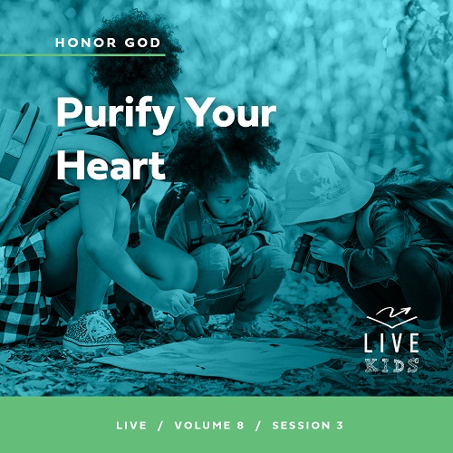

**Volume Overview**

**Honor God**

*Most people think of worship as exclusively songs and music. We think worship is something we do in a service on Sunday mornings. But the Bible calls us to give our entire life as worship. We honor God with our songs and praise, but all of life is an opportunity to show God honor. We worship best when we make it a lifestyle, expressing our gratitude, prioritizing our time with Him, purifying our heart and actions, and generously sharing with others. We worship as we honor God with our whole life.*

**Session Overview**

**Purify Your Heart**

*In this* **Live** *session, kids will discover that being concerned with religious traditions is not as important to God as having a pure heart and relationship with Him. God cares about what is in our heart because that drives the motives behind our actions. God is honored when we choose to do what He says is right.*

**Bible Lesson**

Religious Leaders Learn about Real Purity

[Mark 7:1–20](https://ref.ly/logosref/Bible.Mk7.1-20)

**Faith Fact**

I will do what God says is right.

**Faith Verse**

[Psalm 86:12](https://ref.ly/logosref/Bible.Ps86.12) (NLT)

With all my heart I will praise you, O Lord my God. I will give glory to your name forever.

**Preparing for the Session**

**Leader Preparation Time: 20–25 Minutes**

|  |
| --- |
| ***You Will Need***  ***Large Group***   * *Bible* * *Cup* * *Worship songs (Song suggestions: “Alive” Lyric Video by Hillsong Young & Free; “Make Room” Lyric Video by Community Music; “Great Are You Lord” by All Sons and Daughters; “Only King Forever” Lyrics Video by Elevation Worship)* * *For groups not using a phone or tablet only, add:*   *• Projector or TV*  *• Laptop*  *•* ***Faith Fact Slide***  ***• Faith Verse Video or Slide***  ***• Bible Lesson Video***  ***• Teaching Point Slides 1–3***  ***• Teaching Time Slide***   * *Hand soap* * *Leader’s favorite snack food*   ***Small Group***   * *Clear glasses, two per group* * *Water* * *Bleach* * *Food coloring* * *Dry erase marker* * *Wet wipes* * *Spoon or stir stick* * *Bibles for kids in the group to share* * ***Small Group Faith Verse Review Page****, one per group* * *Optional: Pink or red copy paper* * *Scissors* * ***Small Group Activity Page****, one per kid* * *Markers*   *To access session content and videos from a computer, visit:* [*BibleEngagementProject.com/downloads*](https://bibleengagementproject.com/downloads) |
| ***Getting Ready***  ***Large Group***   * *Download videos and slides if needed.* * *Select worship song(s) and have them ready to play.* * *Read the Bible Lesson Scripture to prepare for teaching time.*   ***Small Group***   * *Fill one glass halfway with water.* * *Fill one glass halfway with a mixture of half water and half bleach. Take care to keep the bleach away from the kids.* * *Print the* ***Small Group Faith Verse Review Page****, one per group.* * *Cut apart the Faith Verse words.* * *Hide the Faith Verse words around the room before the kids arrive.* * *Print copies of the* ***Small Group Activity Page****, one per kid.*   *First time leading* Live *for Kids? Check out the* [*Facilitator Guide*](https://0b769b0ed3569ef9d18b-f88d8272f61086866d50d048b43ef630.ssl.cf2.rackcdn.com/sites/biblengagementproject/Listen_Facilitator_Guide.pdf)*.* |

**Large Group**

**30 Minutes**

*See what’s needed at the beginning of the session.*

**Introduction**

Welcome, everyone. I’m glad you’re here today! We’ve talked about how we can honor God by being thankful and putting Him first in how we spend our time. We can also honor God through our thoughts, words, and actions. All of those are expressions of what’s in our heart. What does that mean? If we allow negative things into our heart and mind, that’s what’s going to come out in our words and actions.

• *Insert a personal story about a time when you allowed negativity to affect your words or actions. Try to keep it light and something kids can relate to if possible.*

• *If you can’t think of a personal story immediately, tell a story about someone else making poor choices after allowing negative things into their life.*

When we honor God and spend time with Him *(hold up the Bible),* positive things will influence our words and actions. God wants us to commit to having a pure heart, but what exactly does that mean? Let’s find out what Jesus taught about it.

**Faith Fact**

Our Faith Fact helps us understand how to have a pure heart. It is **I will do what God says is right.**

• *Show the* ***Faith Fact Slide.***

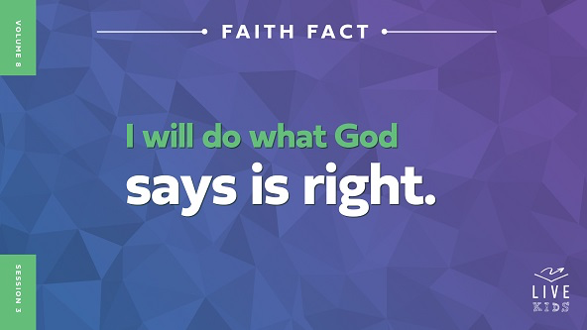

Let’s say the Faith Fact again. Let’s run in place until we say the word *right*. Then, we’ll stop and give two thumbs up. Let’s give that a try. **I will do what God says is right.** Let’s try it one more time. **I will do what God says is right.**

**Game**

**Heart, Head, Do**

|  |
| --- |
| ***You Will Need***   * *Cup*   *No prep is needed for this activity.* |

God cares about where our heart is, and He doesn’t just mean in our chest. What does He mean? Our heart represents what and who we love. He doesn’t just care about what we do. He cares about why we do it. Are our motives and desires what He wants them to be?

For example, showing up here today is something we do. Why we’re here is even more important. God wants us to come because we want to grow closer to Him. Many people make their decisions without really thinking about their motives. God wants us to make the right choices from a pure heart that is seeking after Him.

We are going to play a fun game called “Heart, Head, Do.” I’ll pick two kids for each round, but everyone can play from your seats. *(Demonstrate the following actions.)* When I say, “Heart,” make a heart shape with your hands over your heart. When I say, “Head,” point to your head. When I say, “Do,” roll your fists at your waist. Let’s practice those actions together.

• *Say the words in random order and review the actions with the kids.*

• *Then, hold up the cup.*

Great! I think you’ve got it. The two kids I choose will come stand by me. They’ll do the actions to match the words I say until I say, “Cup.” Then, the first kid to grab the cup wins the round.

• *Place the cup on the floor in front of you.*

• *Form teams. Consider playing boys against girls if that works for your group.*

• *Choose the first two kids to face off. Have the volunteers stand in front of you on either side of the cup.*

Everyone, remember you are welcome to play along. It’s good practice. Just reach down and touch the floor when I say, “Cup.”

• *Randomly say, “Head, heart,* or *do,” making sure kids are doing the actions. Then, say, “Cup,” to determine the winner of the round.*

• *Play as many rounds as you like, choosing two new kids to face off for each round.*

• *Congratulate the winning team, if applicable.*

Great job, everyone! This game is a great reminder that the motive behind what we do is important. What’s in our heart really counts. Let’s worship God by singing, and then we’ll see what Jesus had to say when He talked with some religious leaders.

**Worship**

For us to do what is right, we have to know what God says is right. One of the things God tells us to do in His Word is to worship Him. The Book of Psalms is about praising God through song. Let’s honor God with our worship in song right now.

• *Lead the kids in singing one or two praise songs. See suggestions at the beginning of the session.*

**Bible Lesson**

It’s always great to spend time in worship of God. Let’s pray and ask God to help us learn more about how to have a pure heart and make the right choices as we study the Bible together.

**Prayer**

|  |
| --- |
| *Dear God, thank You for giving us what we need in Your Word to know how to make the right choices. Help us to learn what it means to keep our heart pure. Amen.* |

**Video Intro**

Just before we look at the Bible story, let’s watch this video.

• *Play* ***Bible Lesson Video****.*

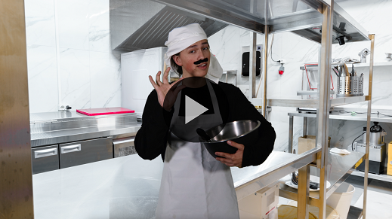

**Bible Story**

**Religious Leaders Learn about Real Purity**

Dash’s cake disaster was a great lead-in to our Bible story today! When Jesus lived on the earth, He ministered to people and took care of their needs. He was teaching His disciples to do that, too. Some of the religious leaders didn’t like the way Jesus and His disciples did things. These leaders often looked for a chance to point out what Jesus and His disciples were doing wrong. Let’s read what happened during one of the many times the religious leaders tried to call out Jesus and His disciples in front of others.

**Teaching Time**

|  |
| --- |
| ***You Will Need***   * *Hand soap* * *Leader’s favorite snack food*   *No prep needed for this activity.* |

Can you imagine someone having the guts to stand up against Jesus and tell Him that what His disciples were doing was wrong? *(Group response)* Well, many of the religious leaders didn’t believe that Jesus was who He said He was. They also felt threatened by His ministry. They believed that their laws and traditions were the most important thing to worry about, but Jesus didn’t agree with them. Who do you think was right? *(Group response)* Jesus, of course!

Our Faith Fact reminds us God is always right, and we should do what He says. Let’s say it together. **I will do what God says is right.** Let’s read about how Jesus responded to the religious leaders and their accusing questions. Grab your Bible or pull up a Bible app on your device. Turn to [Mark 7:1–20](https://ref.ly/logosref/Bible.Mk7.1-20).

• *In order to keep Large Group time moving along, we recommend that the leader reads the Scripture portions aloud.*

• *Optional: Remind the kids to mark this place with their Bible bookmark so they can read it on their own at home.*

**1. The religious leaders focused their hearts on traditions.**

• *Show the* ***Teaching Point 1 Slide.***

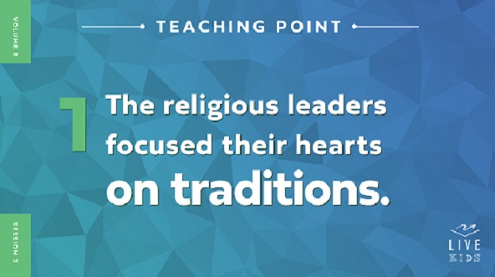

• *Read* [*Mark 7:1–5*](https://ref.ly/logosref/Bible.Mk7.1-5)*.*

I have a funny question to ask all of you. I hope you’ll be honest with me in how you answer it. *(Hold up the bottle of hand soap.)* Raise your hand if you sometimes eat food without washing your hands first. *(Group response)* I don’t think any of us are perfect about always washing our hands. It’s a great idea to wash away the germs on our hands, but we don’t always remember to do it.

The religious leaders were concerned about handwashing but not because of the germs. They had a very specific rule about washing hands before eating. They never ate anything until they had performed their handwashing ceremony, and they watched to make sure other people washed their hands as well.

Clearly Jesus’ disciples didn’t follow the rule of handwashing in the same way because they didn’t always follow it. But, the religious leaders decided to point out that Jesus’ disciples had done something wrong according to their traditions. It’s likely they asked this question in public on purpose, so many people would have heard their accusation. But all that did was give Jesus the opportunity to teach even more people what was right. Jesus told the religious leaders that their hearts were in the wrong place.

**2. Jesus told them that their hearts were in the wrong place.**

• *Show the* ***Teaching Point 2 Slide.***

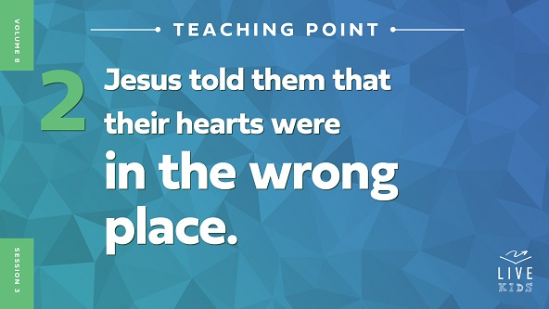

• *Read* [*Mark 7:6–13*](https://ref.ly/logosref/Bible.Mk7.6-13)*.*

Jesus didn’t hesitate to come right back at the religious leaders and point out just how wrong they were. He didn’t sugarcoat His words or go easy on the religious leaders either. He called them hypocrites. He called them that because they said they worshipped God, but in their hearts they didn’t serve Him. That was a harsh accusation! It’s like Jesus could see what was inside each person’s heart.

*Show the* ***Teaching Time Slide.***

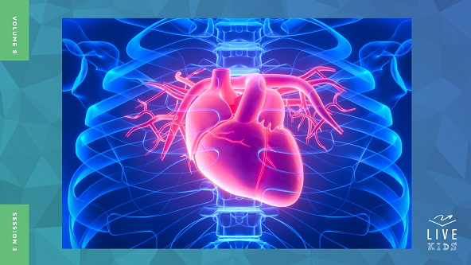

It’s like these leaders had made one rule to try to get out of following a more important one. Here’s an example. The school rule is no fighting is allowed for any reason. To get around that rule someone joins the school boxing team so they could fight and try to hurt someone they didn’t like. Jesus knew that the religious leaders were great at saying they followed God, but their hearts were far from Him. Let’s find out what God says a pure heart really looks like.

**3. Jesus taught what real purity looks like.**

• *Show the* ***Teaching Point 3 Slide.***

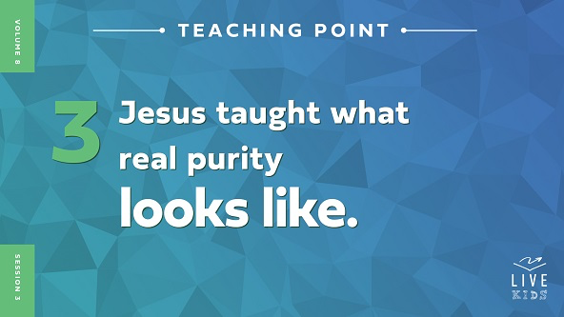

• *Read* [*Mark 7:14–20*](https://ref.ly/logosref/Bible.Mk7.14-20)*.*

Jesus took the opportunity to teach the crowd what God says a pure heart really looks like. Back in those days, the Jewish people had a lot of laws, or rules, about things like which foods they could or couldn’t eat. Let’s think about that. What are some of your favorite foods to eat? *(Allow responses.)*

• *Hold up your favorite snack food and tell the kids about it.*

Can you imagine if you were told you could never eat that food again? And, if you did eat it, you weren’t allowed to go to church for a few weeks? That’s kind of like what certain Jewish laws said. It may seem odd to you, but there were reasons behind those laws for a time. Jesus was about to change a lot of that!

Jesus said something very shocking to the crowd. He told them that what you eat isn’t the problem. It’s what comes from your heart that makes you unclean. If we keep on reading this passage of Scripture, Jesus gave some examples of what having evil in your heart leads to—evil thoughts, stealing, lying, and more. Avoiding those is much more important to show we’re living for God than what we eat and if we wash our hands. He said all that to remind us who we should listen to. Who is that? *(Group response)* That’s right. God. That’s why our Faith Fact is so important to remember. Let’s say it together. **I will do what God says is right.**

**Prayer and Response**

*Consider playing a worship song softly in the background while kids pray.*

I think it’s a good idea for us to end our time together by doing a quick “heart check.” We all struggle with sin in our life sometimes. God wants to clean our heart and make it pure again. How do we clean our heart? We ask Jesus to forgive our sins. He not only can forgive us and clean those things out of our life, but He will also give us a pure heart that honors Him. Let’s sit quietly and ask the Holy Spirit to show us anything that gets in the way of putting God first.

• *Have kids sit quietly and pray. Then close in prayer.*

**Prayer**

*Optional: Have the kids repeat phrases of the prayer after you.*

|  |
| --- |
| *Dear God, thank You for showing me what it means to have a pure heart. Help me to clean my heart by asking for Your forgiveness so I can make the right choices that honor You. Amen.* |

**Faith Verse**

Our Faith Verse tells us to praise God with our whole heart. We can only do that if our heart is pure and honors Him. Let’s say our Faith Verse and do the actions together.

• *Play* ***Faith Verse Video****.*

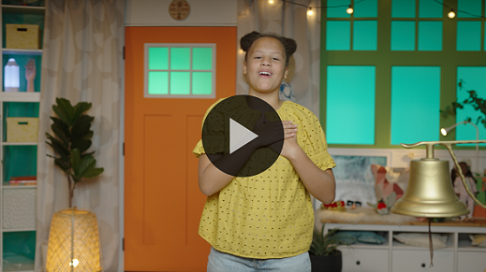

[Psalm 86:12](https://ref.ly/logosref/Bible.Ps86.12) (NLT)

With all my heart I will praise you, O Lord my God. I will give glory to your name forever.

**Faith Fact**

Before we go to our small groups, let’s review our Faith Fact again. **I will do what God says is right.**

• *Show the* ***Faith Fact Slide****.*



This time, let’s make the heart shape with our hands *(demonstrate)* as a reminder that when we do what is right, our actions come from a pure heart. **I will do what God says is right.** Remember to ask God to help you know what the right choices are.

• *Dismiss kids to Small Group time or to go home if your group time ends here.*

**Small Group**

**30 Minutes**

*This section can be done in conjunction with the large group or on its own if you do small groups with your kids. During Small Group time, the goal is to connect the kids with the Word of God and to each other. All activities are led by the small group leader.*

**Group Connection**

**Clean-Up Object Lesson**

|  |
| --- |
| ***You Will Need***   * *Clear glasses, two per group* * *Water* * *Bleach* * *Food coloring* * *Dry erase marker* * *Wet wipes* * *Spoon or stir stick*   ***Getting Ready***   * *Fill one glass halfway with water.* * *Fill one glass halfway with a mixture of half water half bleach.* |

In today’s Bible story, we learned how important it is to do the things that God tells us to do. When we follow the things He says and ask Him to forgive our sins, our heart can be clean. It’s like this glass with water in it.

• *Hold up the first glass with only water in it.*

• *Make sure kids are seated a safe distance away from you.*

Right now, the glass and the water are very clear and clean. What if I take my marker and draw on the glass?

• *Use the dry erase marker to draw on the glass.*

It gets a little harder to see the clean water if the glass is dirty on the outside. What if I add food coloring to the water on the inside?

• *Add the food coloring to the water, and stir it if needed. Consider adding multiple colors to turn the water a dark color.*

Does the water look clean anymore? *(Group response)* Do you think I can clean up the mess I made without throwing it away? *(Group response)* Maybe if I wipe off the marks I drew on the glass. Do you think that will help? (*Group response)*

*•* *Wipe off the glass using the wet wipes.*

Hmm. I cleaned the outside, but remember what we learned in our Bible story today? Just because the outside is clean doesn’t mean that the inside is. Our actions might look right, but our heart has to be clean, too. I can’t clean out the food coloring to make the water clear again. The same thing is true with our heart. We can’t forgive our sins on our own. Only God can do that and give us a clean heart.

• *Pick up the other glass with the bleach mixture.*

I have another glass here. It looks just like the glass of water, but I added something extra to it. Let’s see what happens when I pour it into our dirty water.

*•* *Pour the bleach mixture into the first glass. Pause and watch as the bleach takes the color out of the water.*

Wow! That was amazing! I knew exactly what was needed to make this water clean again, and God knows exactly what we need to clean us from the inside out. That’s why it’s so important to do what God says. That’s what our Faith Fact says. Why don’t we say it together? Ready? **I will do what God says is right.** Great job, everyone!

**Bible Lesson Recap**

• *If small group activities are not immediately following large group time, you may want to read the Bible story passage before the discussion.*

|  |
| --- |
| ***You Will Need***   * *Bibles for kids in the group to share*   *No prep needed for this activity.* |

**Bible Story Review: Religious Leaders Learn about Real Purity** [**Mark 7:1–20**](https://ref.ly/logosref/Bible.Mk7.1-20)

One day some of the religious leaders came from Jerusalem because they wanted to see Jesus. Now, you might be thinking that they wanted to hear Jesus’ teaching or learn something from Him, but that wasn’t what we see in the Bible story. They were watching Jesus and His disciples closely. What did they complain to Jesus about? *(Allow responses.)*

They didn’t like that Jesus’ disciples failed to perform the handwashing ceremony before they ate as the leaders’ traditions required. The religious leaders noticed this and asked Jesus why His disciples didn’t follow their tradition.

Jesus was ready for their accusation. He had something to say about their hearts and the motive behind their question. He told them that their traditions and religious rituals didn’t matter because their hearts matter more to God. Jesus saw right through their religious rules to what their motive was. Jesus used the opportunity to teach the people and His disciples about what was really important. He taught them to have a pure heart that honors God instead of worrying so much about religious traditions.

• *Give each kid a Bible and read the Bible story together.*

**Group Discussion**

*Feel free to use all or just a few questions as a jumping-off place for good discussion. Questions marked with * are designed for more conversation. Adjust the questions based on the age or maturity of your group. Typically, older kids will be able to dive a little deeper than younger ones.*

**Questions**

In this Bible story, which Jewish ritual did Jesus’ disciples not follow?

Jesus called the religious leaders hypocrites ([Mark 7:6](https://ref.ly/logosref/Bible.Mk7.6)) because their actions didn’t match what they claimed to believe. Does it surprise you that Jesus said called these men that name? Why or why not?

What emotion do you think Jesus was feeling when the religious leaders accused His disciples?

Why do you think Jesus’ disciples didn’t follow all of the Jewish rituals?

What did Jesus say is more important: religious traditions or a relationship with God? Why?

If you had been there, how do you think you would have reacted to the religious leaders and Jesus’ response?

What are some religious traditions Christians follow today?

* How can we focus more on having a relationship with God than on just being religious?

**Live It**

**Faith Fact**

Our Faith Fact today is **I will do what God says is right.** What God says is right is the only thing we should be concerned with. It doesn’t matter what other people think or say. Honoring God should be our main priority.

**Challenge**

Let’s focus on having a pure heart this week. What does that mean? Each day, ask God to check your heart and see if there is anything wrong or negative that you are allowing to be in your life. What we allow inside our heart and mind determines what will come out through our words and our actions. You might realize that you have been doing, listening to, or watching things that are affecting the purity of your heart. God may tell you to stop doing something so He can clean your heart and honor Him. We need to be willing to do what God says is right.

**Prayer**

*Finish group discussion by sharing prayer requests and praise reports. Keep track of your small group’s prayer requests and review them each time you meet.*

• *Have kids share and pray for each other’s prayer requests.*

|  |
| --- |
| *Dear God, help us not to be like the religious leaders in the Bible story, pretending to be close to You when our heart is far away from You. We want our heart to be pure and to honor You in everything we say and do. Amen.* |

**Faith Verse Review**

|  |
| --- |
| ***You Will Need***   * ***Small Group Faith Verse Review Page****, one per group* * *Optional: Pink or red copy paper* * *Scissors*   ***Getting Ready***   * *Print the* ***Small Group Faith Verse Review Page****, one per group.* * *Cut apart the Faith Verse words.* * *Hide the Faith Verse words around the room before the kids arrive.* |

Our Faith Verse talks about committing our whole heart to praising God. He deserves all the glory and praise. Let’s review it now.

• *Show* ***Faith Verse Video****.*



[Psalm 86:12](https://ref.ly/logosref/Bible.Ps86.12) (NLT)

With all my heart I will praise you, O Lord my God. I will give glory to your name forever.

Let’s say it together a couple of times before we do a fun Faith Verse activity together.

* *Say the verse as a group a couple of times.*

**Faith Verse Fun**

**Hide the Hearts**

The Faith Verse words are hidden around the room. Your challenge is to collect all the hearts and put the Faith Verse in order. Are you ready to play? *(Group response.)*

• *Let the kids complete the activity.*

You were so fast at collecting those hearts! I want to challenge you to hide this Faith Verse in your heart by memorizing it if you haven’t already. Praising God is one way to keep our heart centered on Him.

• *Have the kids return the verse words to their hiding places if there is another group that will follow this one.*

**Activity Page**

**Heart Art**

|  |
| --- |
| ***You Will Need***   * ***Small Group Activity Page****, one per kid* * *Markers*   ***Getting Ready***   * *Print copies of the* ***Small Group Activity Page****, one per kid.* |

Our hearts have been the focus of today’s discussion. God wants us to have a heart that reflects His presence in our life.

• *Hand out a copy of the* ***Small Group Activity Page*** *and markers to each kid.*

For this activity, design your heart to show how it should look when you are doing what God says is right. What colors and patterns represent that to you? When you’re done, show us your creative design.

• *Give kids time to create their design.*

**Dismissal**

I’m so thankful for Jesus’ instruction to check our heart. As followers of Jesus, we should want our heart to be pure and our life to be full of things that honor God. We need to get rid of any junk and fill our heart with what God says is right. Let’s pray and ask God to purify our heart.

**Prayer**

|  |
| --- |
| *Dear God, we want our heart to be pure and filled with what You say is right. Help us to get rid of the junk that is dirtying up our heart. We want You to fill us with the things that honor You. Amen.* |

**Faith Fact Recap**

• *Show the* ***Faith Fact Slide****.*



Keeping our heart pure by doing what God says is right is a lifelong commitment. Other people around us may choose to do the wrong things and think we should, too. But, we can remain pure by choosing to do the right things. Remember today’s Faith Fact as you go. **I will do what God says is right.** God’s way is always the best way.

Next time, you’ll have a chance to show us a special talent you may have. So if you play a musical instrument or can do fifty push-ups in five minutes or can tell a funny story or any other talent, come prepared.

• *Send home the* ***Small Group Activity Page.***

• *Remind parents that there are* ***Family Devotions*** *available on the app to do with their kid.*

• *Tell everyone the date and time for the next session.*